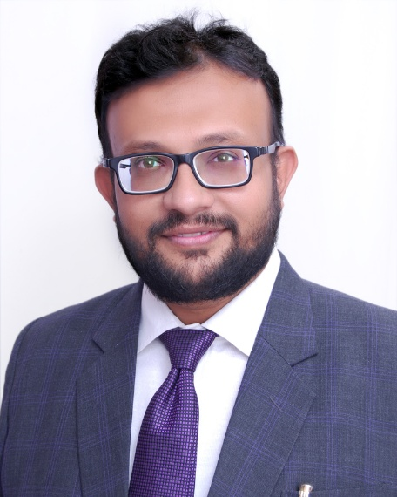
Dr Sadeq Qureshi
MBBS, DPM, DNB
Consultant Neuropsychiatrist
Deaddiction Specialist
Child and Adolescent Psychiatrist
Director- Prerna Hospital LLP

Overview

MEMBERSHIPS & POSITIONS:

Experience :
* ﻿﻿MBBS from Government Medical College, Aurangabad
* ﻿﻿DPM from B.J. Medical College and Sasoon general hospital Pune
* ﻿﻿DNB fom "Asha Hospital" Hyderabad
* ﻿﻿6 months special training in child and adoloscent Psychiatry
* ﻿﻿Ex-Consultant Psychiatrist at Jalna Civil Hospital
* ﻿﻿Ex-Senior Resident, Department of Psychiatry Govt Medical College Aurangabad
* ﻿﻿Currently Asst. Professor at JIIU's IIMSR Medical college BadnapurJalna
* ﻿﻿Research Asst. MIMH Pune
* ﻿﻿Co-Investigator and Rater in 10 multicentric international clinical trials & research projects
* ﻿﻿Visiting Consultant at Malegaon and Vaijapur

Awards Received

Achievements:
* ﻿﻿Winner of Torrent Young scholar award 2013-14
* ﻿﻿Ex-Asst. editor Indian General of Psychological Medicine
* ﻿﻿Member of Pankh foundation, a NGO working for mental health awareness
* ﻿﻿Attached to NGO AIPIF for De-addiction awareness
* ﻿﻿Multiple mental health camps for Psychiatric awareness and treatment
* ﻿﻿Workshops for Stress management programs for B.ED and engineering colleges
* ﻿﻿Awareness programs for teachers under School Mental Health &Parenting workshops

